Qualcomm Items for Transfer to DC (NPI Rejects / Aging Material, Handler Kits) Specification
Revision: 1.2
Date: 23rd May 2012

Revision | Date | Author | Description
001 | 30th April 2012 | Ferdinand Caliwliw | Version 1.0
002 | 18th May 2012 | Ferdinand Caliwliw | Version 1.1
003 | 23rd May 2012 | Ferdinand Caliwliw | Version 1.2

Background
As per request by Qualcomm team to help to manage Items for Transfer to DC (NPI Rejects / Aging Materials and Handler Kits) Inventory control system. It should be something that is already present in Exceed and which we can utilize for tracking.

Currently, Items for Transfer to DC is managed in XLS file.

Functions Enhancement in WMS
Be as the functions that Schenker IT need enhance on current WMS to allow to handle Items for Transfer to DC (Aged, NPI Rejects and Handler Kits).

- New Storerkey in WMS
As Qualcomm PS were able to differentiate the rejects and non-rejects from the Lot No. there is no need to create different sub-inventory in Exceed. Just one under NPI AGING will do so Schenker will create a Storer in WMS called “TDCNPIAGE” for NPI Rejects / Aging Materials.

Another Storer “TDCHK” will be created in WMS for Items for Transfer to DC (Handler Kits).

Need to changes the WMS programs/scripts to disable any messaging between Schenker and Qualcomm. So no inbound or outbound messages send out for any transaction done in TDCNPIAGE and TDCHK.

Need to enhance all the report to allow user to select by new storerkey (TDCNPIAGE and TDCHK).

- Upload of TDCNPIAGE and TDCHK ASN into WMS
Schenker WMS need to enhance to allow user to upload ASN (refer to defined template).

Qualcomm PS have proposed template for NPI Rejects / Aging Materials.
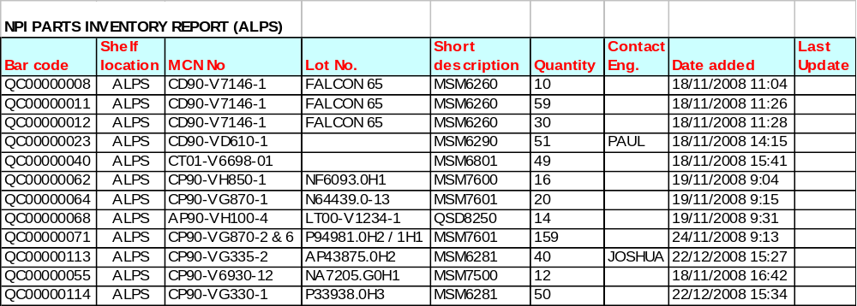

- SKU set up
Qualcomm need to provide SKU master for initial setup or provide SKU list for NPI Rejects / Aging Materials and for Handler Kits.

- Inventory Balance Report

Qualcomm PS would like to receive the Inventory Balance Report on a weekly basis on Fri (same as the tray) attention to TCE_PS.

Operational Flow and Management in WMS.
- ASN/Receipt (Internal Schenker Exceed)

Below as the work flow of the receipt flow;
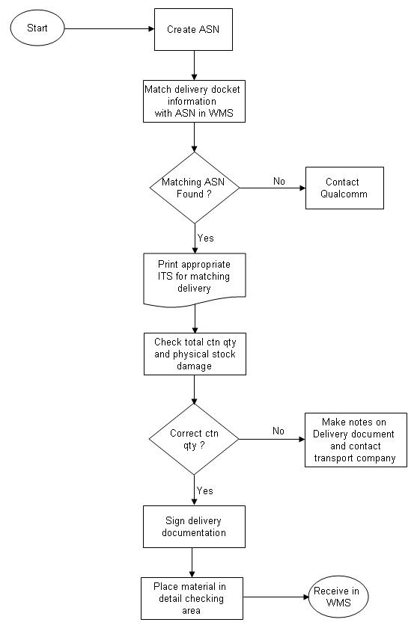

- Outbound (Internal Schenker Exceed)

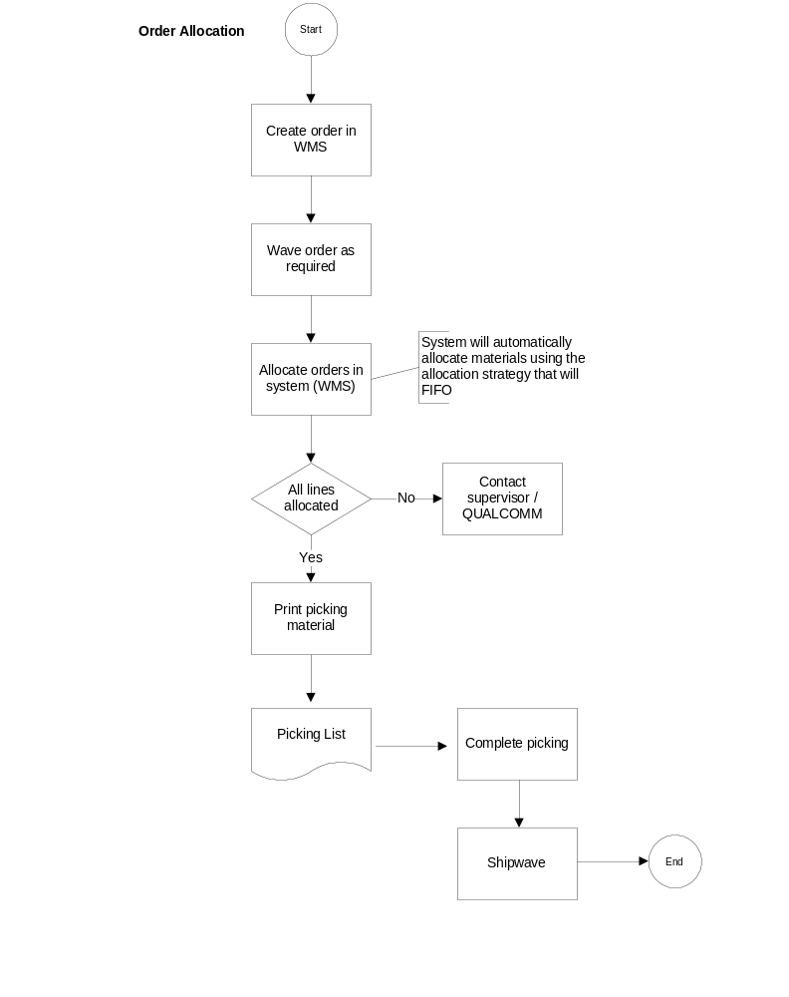Below as process of outbound processing;

